CAC 2000 LIMITED (CAC2000)
MANAGEMENT CHANGE — APPOINTMENT OF CHIEF EXECUTIVE OFFICER
June 30, 2026
CAC 2000 Limited (the "Company") advises that Ms. Gia Abraham will demit office as Chief Executive Officer effective July 1, 2026, after serving in that role for the past 5 years. Ms. Abraham has indicated that this decision is for personal reasons, following 25 years of service to the Company. Ms. Abraham will continue to serve the Company as a Director and will work with the Company on specific internal projects during the transition period.
The Board of Directors is pleased to announce that Mr. Steven Marston, currently Executive Chairman of the Company, will assume the additional role of Chief Executive Officer, effective July 1, 2026, while continuing to serve as Chairman.
Mr. Marston has worked closely with Ms. Abraham during the transition to ensure operational continuity for the Company's stakeholders.
The Board thanks Ms. Abraham for her exceptional leadership and dedicated service over the years and looks forward to the Company's continued growth under the new leadership structure.
This announcement is made in accordance with the Jamaica Stock Exchange Junior Market Rules.
Sincerely,
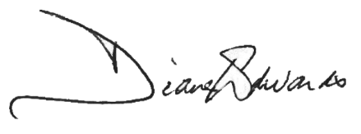

Ms. Diane Edwards
Director
CAC 2000 Limited

